William Enoch Butland – GWR Inquests 1904 – 1905

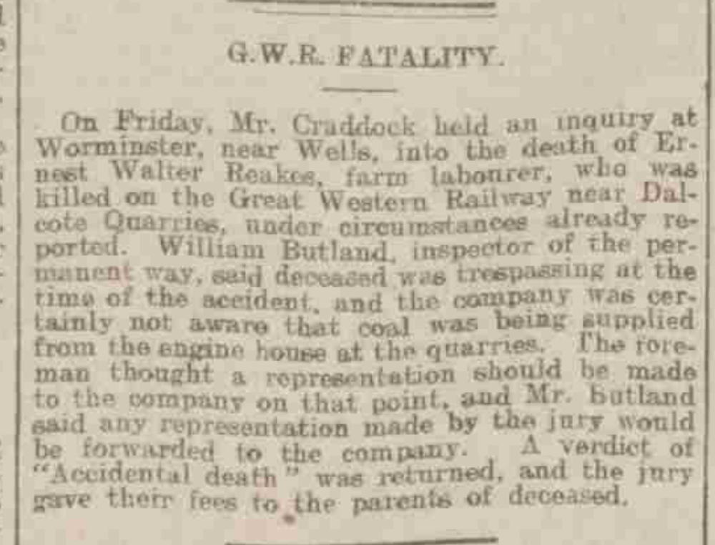
The Bath Chronicle, 24 March 1904

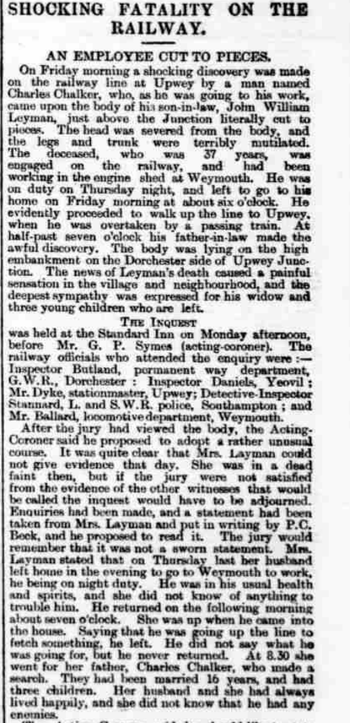
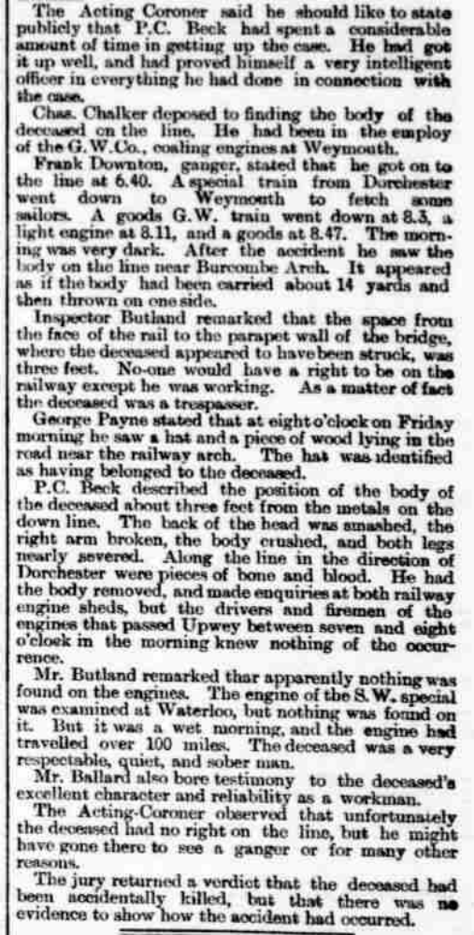
Taunton Courier, 13 December 1905

