William Enoch Butland Articles 1935 – 1939

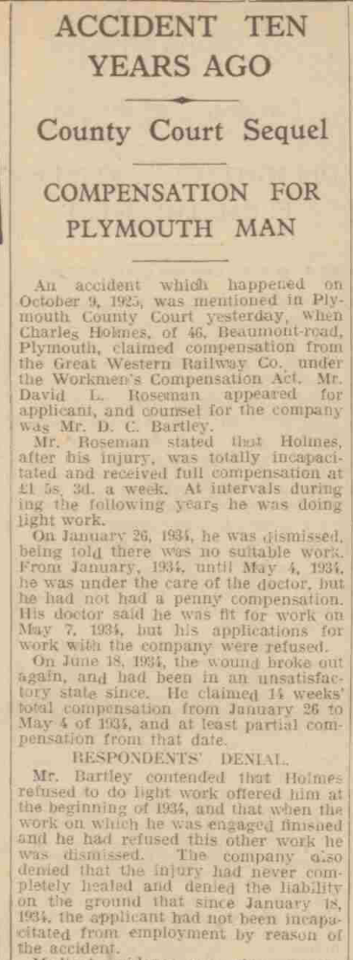

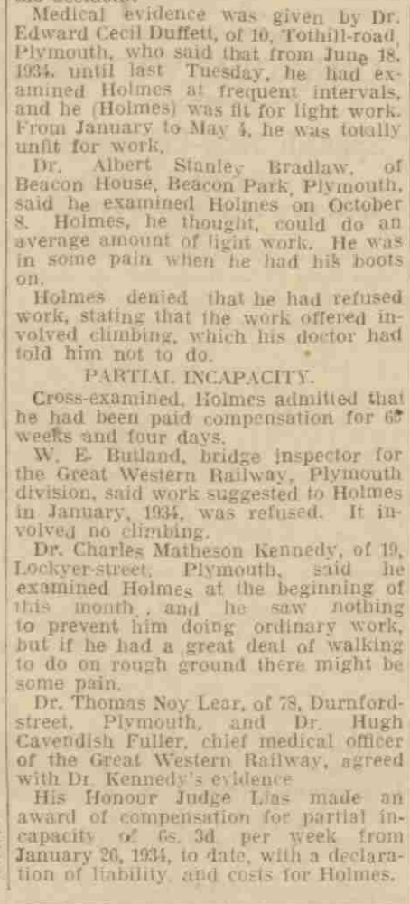
Western Morning News and Daily Gazette, 11 October 1935

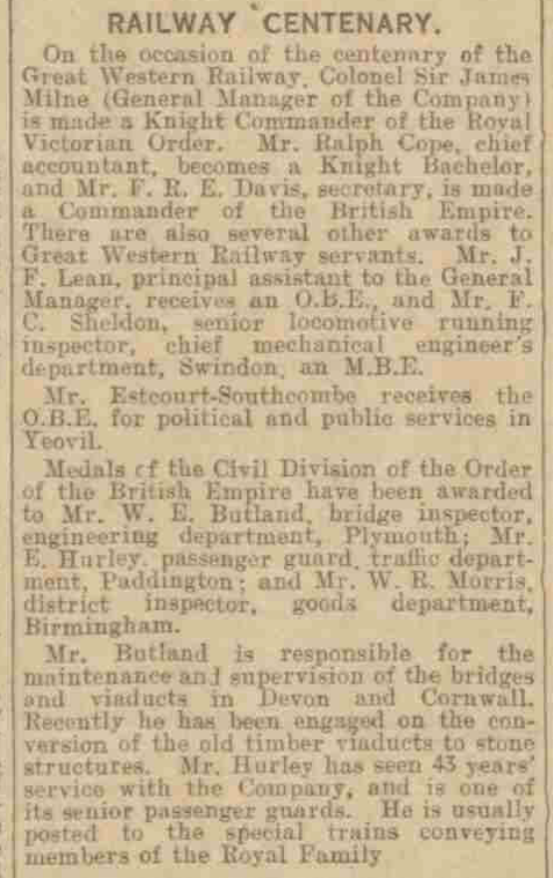
Devon & Exeter Gazette, 3 January 1936

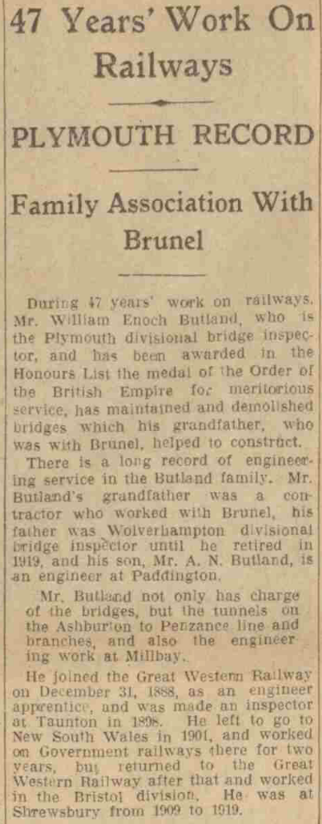
(continued overleaf)
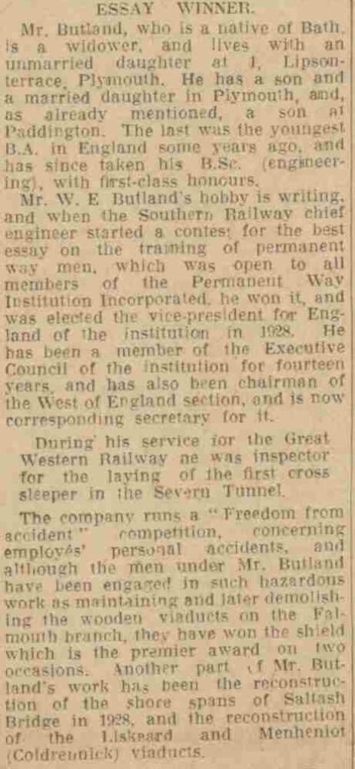
Western Morning News & Daily Gazette, 2 January 1936
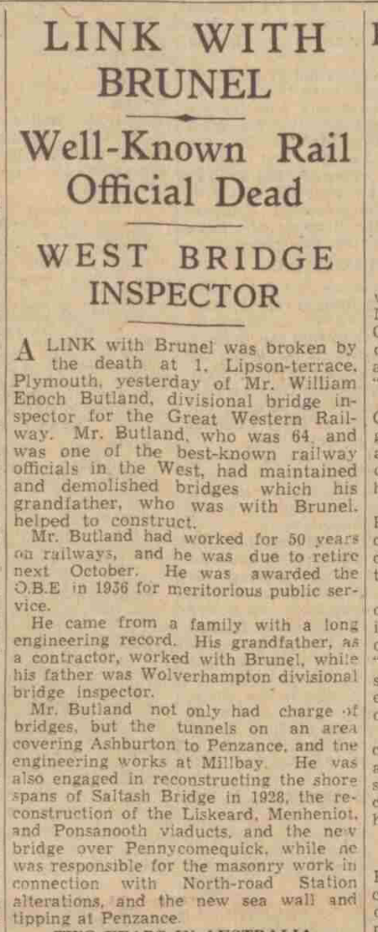
(continued overleaf)
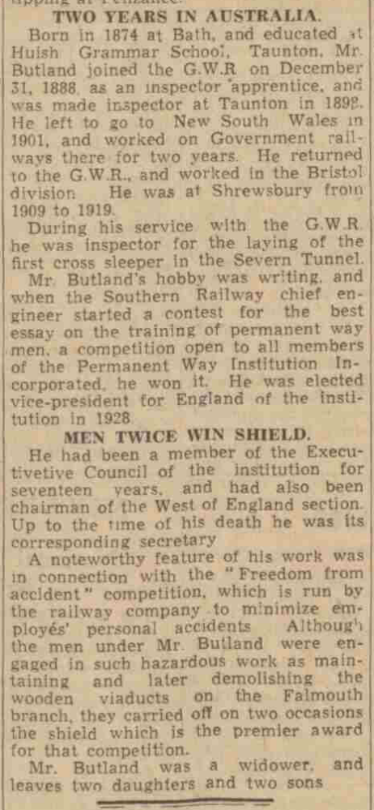
Western Morning News & Daily Gazette, 13 February 1939

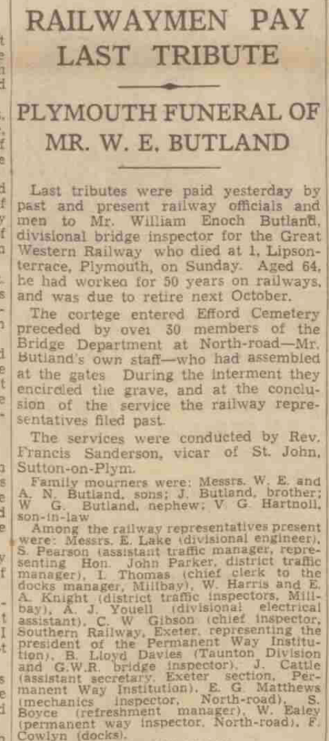
(continued overleaf)
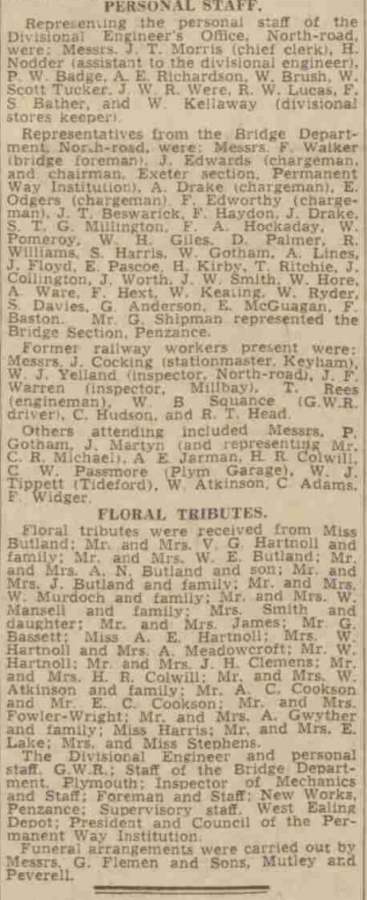
Western Morning News & Daily Gazette, 15 February 1939

