Arthur Norman Butland Articles 1940 – 1966
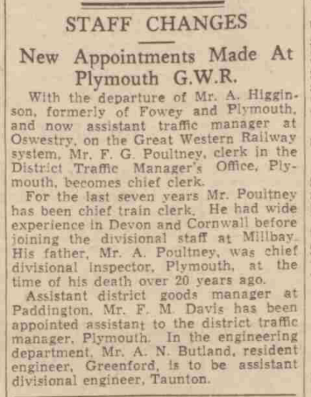
The Western Morning News, 3 February 1940
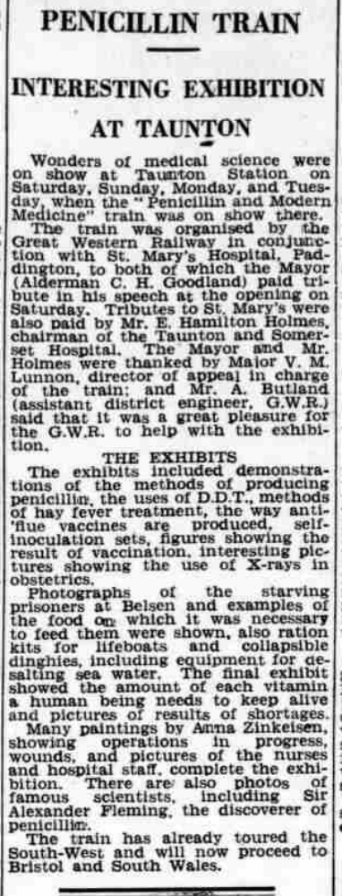
Somerset County Herald, 13 October 1945

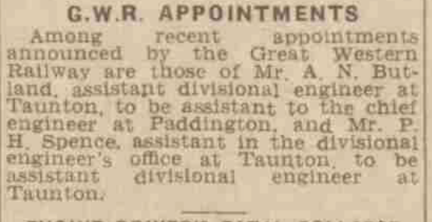
Somerset County Herald, 31 May 1947
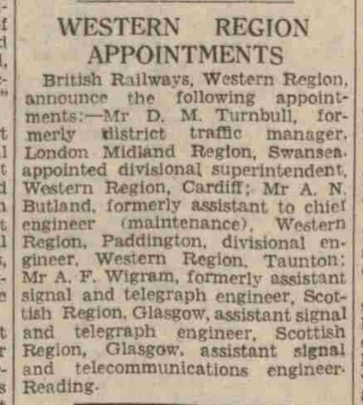
Western Daily Press and Bristol Mirror, 8 November 1948
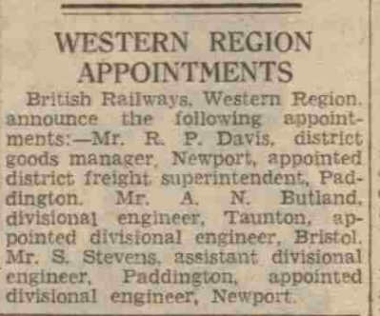
Western Daily Press and Bristol Mirror, 6 April 1949
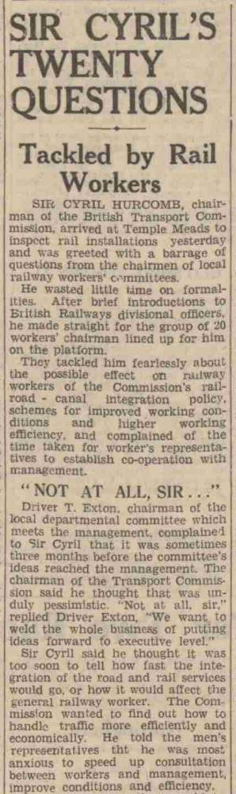

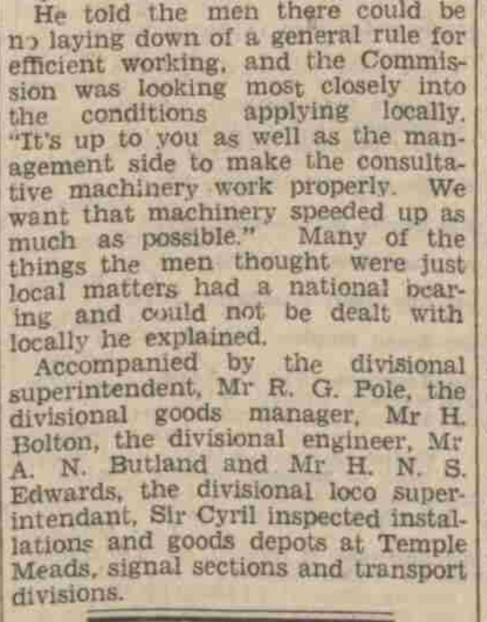
Western Daily Press and Bristol Mirror, 25 October 1949
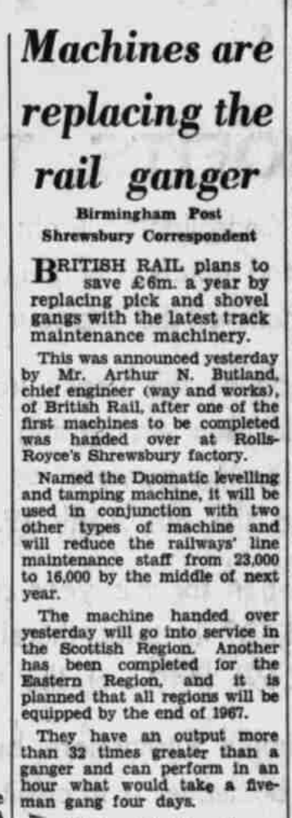
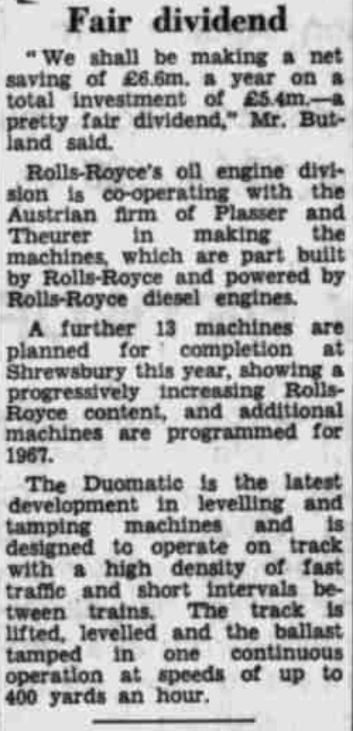
The Birmingham Post, 1 September 1966
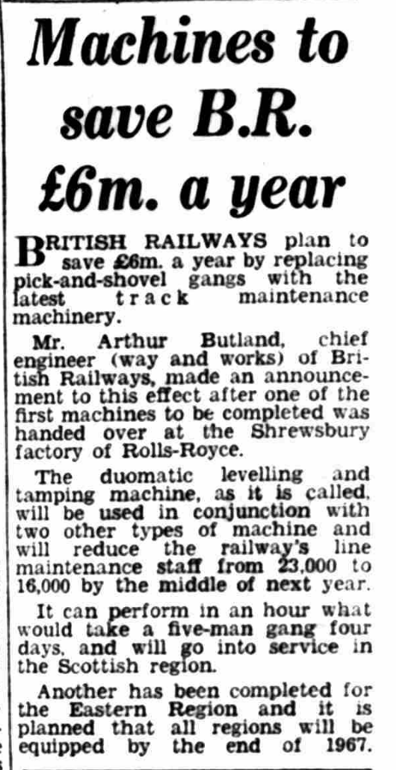
Coventry Evening Telepgraph, 1 September 1966

